# Department of Computer Science

**CS-344: Web Engineering**

**Class: BSCS-6AB**

# Lab 08: jQuery

**Date: April 5, 2018**

**Time: 1000-1300 (BSCS-6B), 1400-1700 (BSCS-6A)**

# Instructor: Dr. Qaiser Riaz

# 

# Lab 08: jQuery

### Introduction:

jQuery is a widely used and well-known library for JavaScript which helps in rapid web development. Most of the modern websites use jQuery as a tool to implement and control client side dynamic behavior of the websites. Students have learned basic and advanced concepts of jQuery during lectures. This lab will help them to further understand these concepts by practically using jQuery in given situations.

### Lab Objectives:

The objective of this lab is helping students to familiarize themselves with basic and advanced concepts of jQuery by practically implementing them in given scenarios. The knowledge students have gained in the lectures will help them to develop and control dynamic behavior of web pages using jQuery.

### Tools:

Notepad, DreamWeaver, browser.

### Helping Material:

Lecture slides.

W3Schools: <https://www.w3schools.com/js/default.asp>

jQuery API: <http://api.jquery.com/>

jQuery Cheatsheet: <https://oscarotero.com/jquery/>

### Lab Task

### Task 1

During lectures, students have seen a basic version of the ‘buy groceries’ example. This basic version is given in ‘grocery-basic-skeleton.html’ file along with CSS and JavaScript (see ‘lab-7-supporting-material.zip’). Using jQuery, you have to change the behavior of the list items <li> as explained below:

1. When you click on any list item <li>, it should display current date and time in the format shown in the image below.

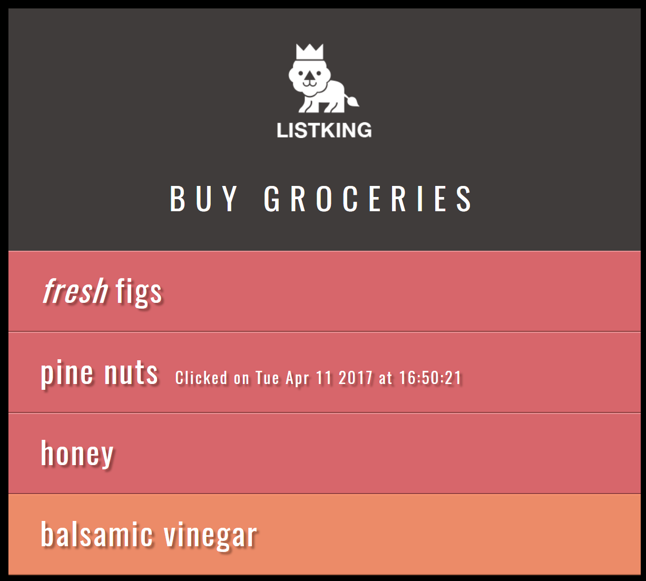

1. Hint: A <span> class ‘date’ is already defined in CSS. You can use it to style date and time.

### Task 2

Using the ‘grocery-basic-skeleton.html’ file, you have to change the behavior of the list items (using jQuery) as explained below:

1. Add a new paragraph after last list item as shown below:

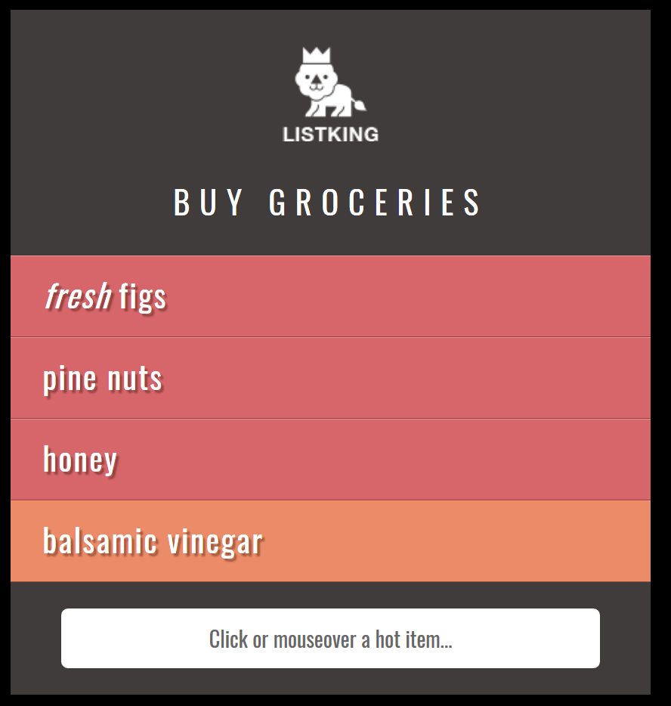

1. When you click or mouse over on any list item <li>, it should display following information:
   1. Item: Name of list item which is clicked or on which mouse over event occurred
   2. Status: Important (for honey and pine nuts), Available (for all other items)
   3. Event: Name of event (click, mouseover)

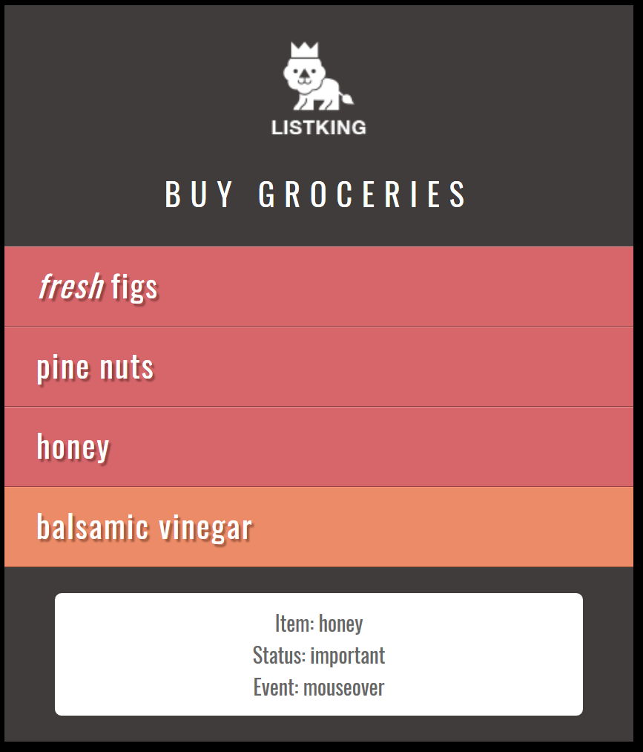

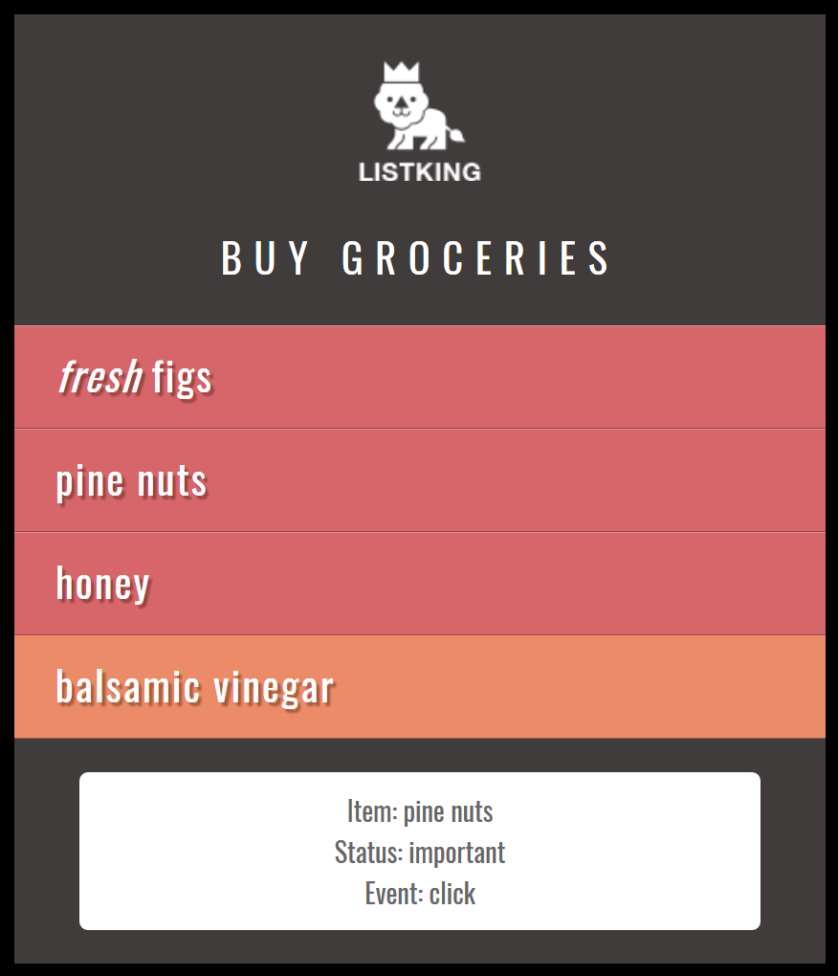

### Task 3

1. Extend the ‘basic-skeleton.html’ file but adding new list items and a footer as shown below (hint: use MS word’s zooming to clearly see the figure):

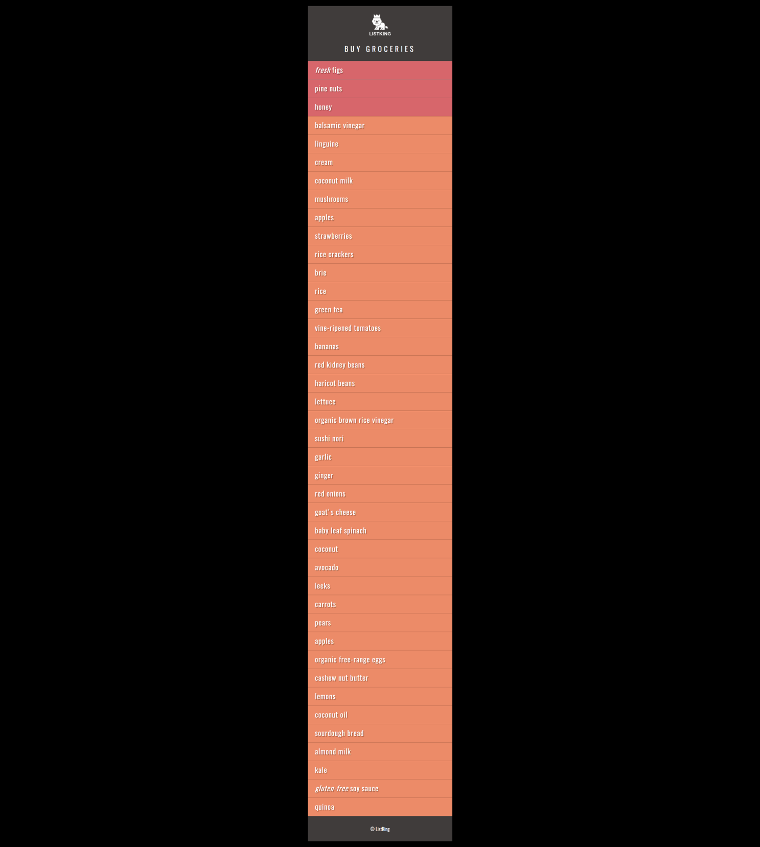

1. When scroll the page down to bottom, a new div appears at the bottom-right side, showing latest promotions:

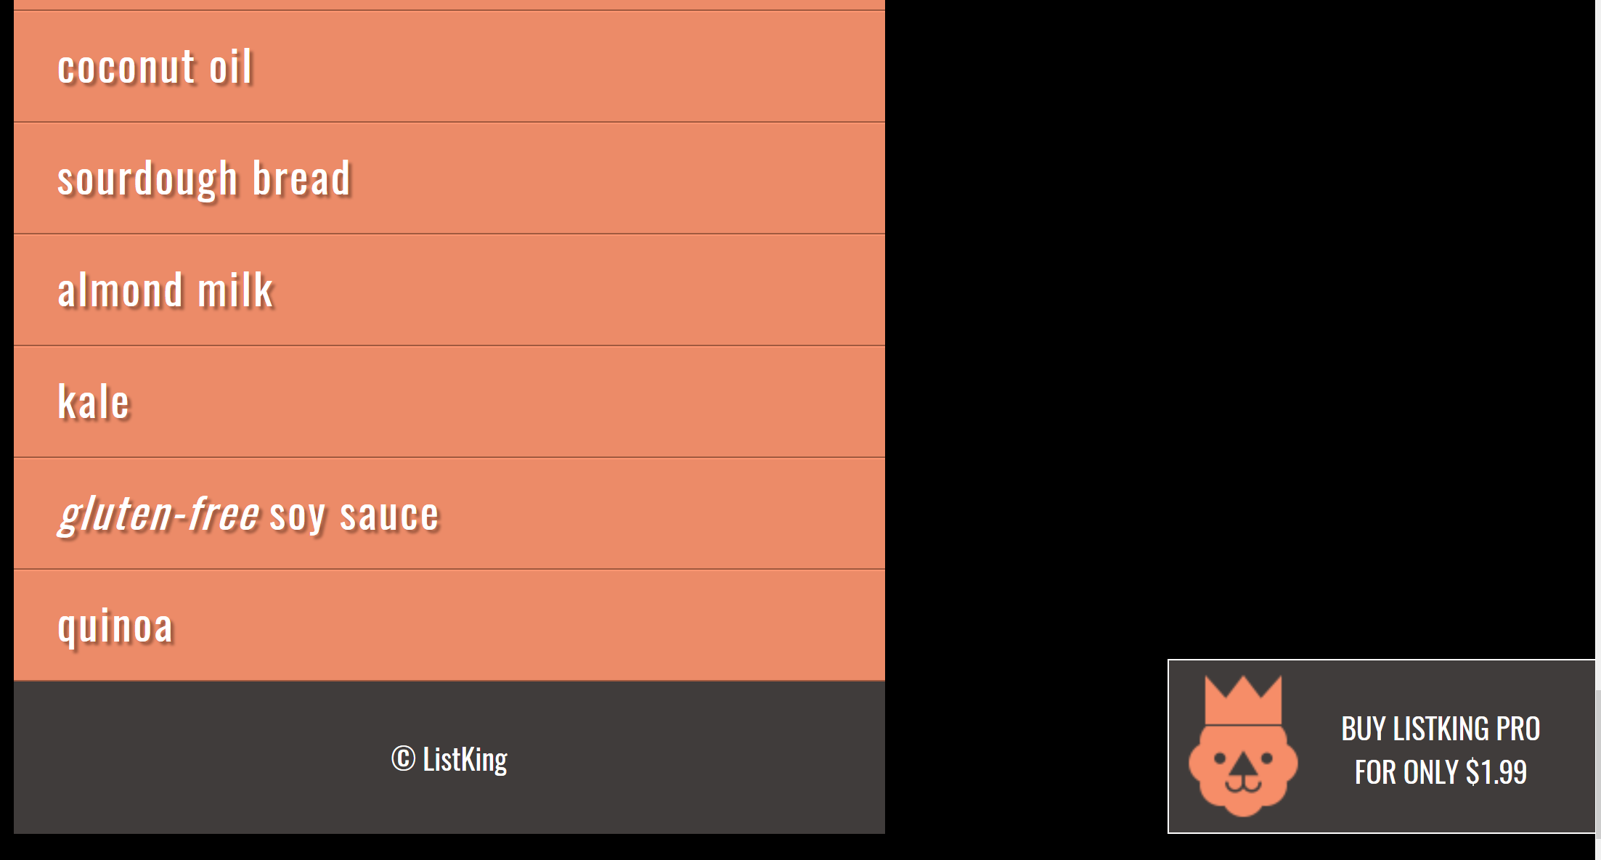

1. The promotion div must disappear as soon as the user scrolls the page up to 500px from the bottom.

**Hints:**

* Use $window.scrollTop() to get the current vertical position of the scroll bar.
* Use following formula to find if the user is within bottom 500px of the page.
  + $('#footer').offset().top - $window.height() – 500
* Use $window.on (‘scroll’, function(){….} to handle onScroll() event of the window.
* jQuery’s animate() function will help you achieving this task.

### Task 4

Extend the ‘task-4-skeleton.html’ file and add following two functionalities using jQuery:

1. Add functionality for ‘add row’ button which should add a new row with the data entered by the user in Name and Email Address text fields. The table should be extended dynamically and new row should be appended at the end.

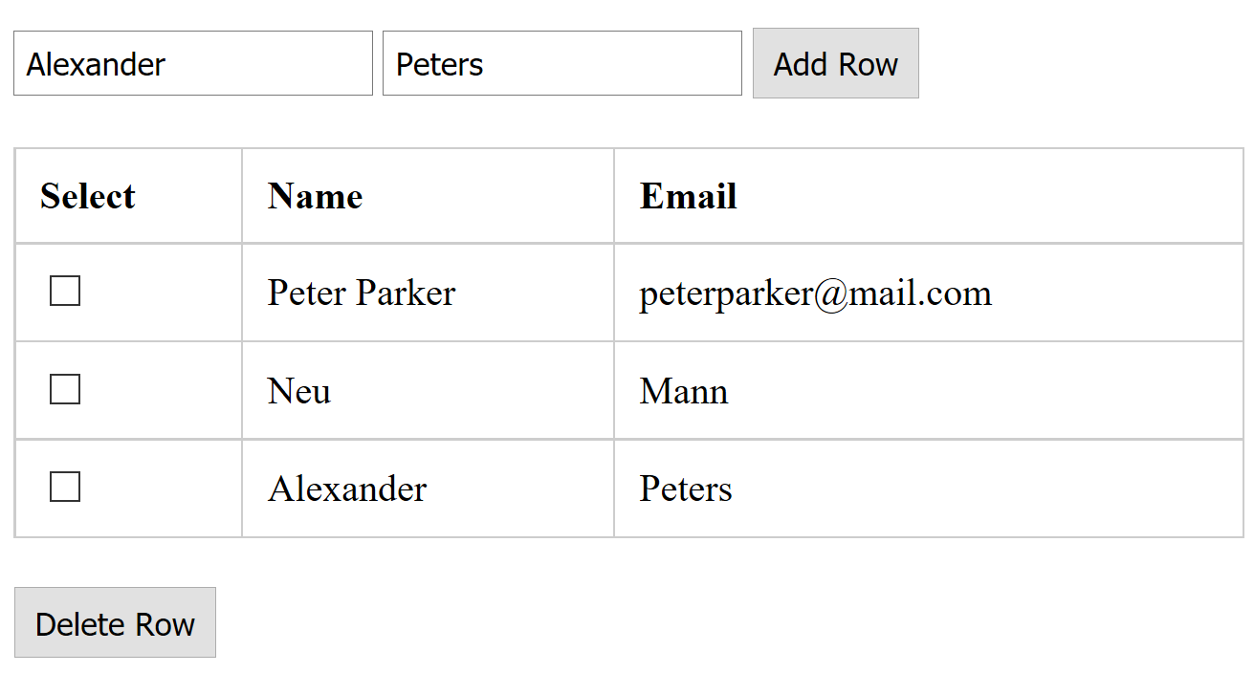

1. Add functionality for ‘delete row’ button which should delete all selected rows.

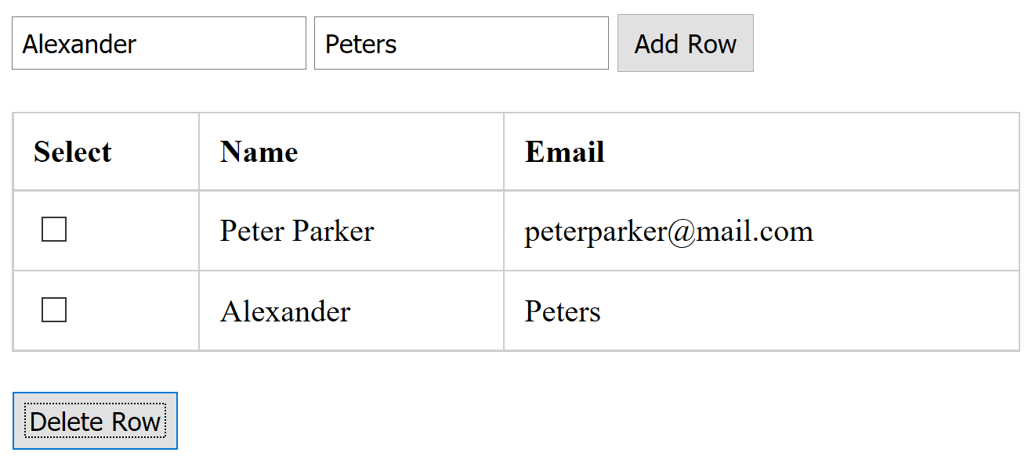

### Deliverables

Compile a single word document by filling in the solution part and submit this Word file on LMS. You must include your name, ID, and class on first page. The lab grading policy is as follows: The lab is graded between 0 to 10 marks. For some of the labs, students have to present their solutions in a viva session. In case of any problems with submissions on LMS, you should contact your lab engineers: Mr. Ahsan Gul - [ahsan.gul@seecs.edu.pk](mailto:ahsan.gul@seecs.edu.pk) or Ms. Ayesha Asif [ayesha.asif@seecs.edu.pk](mailto:ayesha.asif@seecs.edu.pk).